**NAME – SHAIKH ARSHAD AJIJ**

**BRANCH -CSE- ICB**

**BATCH – B1**

**ROLL NO- B007**

**SAP ID – 60019230064**

**DATE – 26/4/20204**

**EXPERIMENT NO. 14**

**AIM / OBJECTIVE:**

**To implement basic Swing programs with event handling**

1. Write java program to create a registration form. Take Login id and Password from the user and display it on the third Text Field which appears only on clicking OK button and clear both the Text Fields on clicking RESET button.

**CODE-**

import javax.swing.*;

import java.awt.*;

import java.awt.event.*;

public class RegistrationForm extends JFrame implements ActionListener {

JTextField loginIdField, passwordField, displayField;

JButton okButton, resetButton;

public RegistrationForm() {

setTitle("Registration Form");

setSize(400, 200);

setDefaultCloseOperation(JFrame.EXIT_ON_CLOSE);

setLocationRelativeTo(null);

setLayout(new GridLayout(4, 2));

JLabel loginLabel = new JLabel("Login ID:");

loginIdField = new JTextField();

JLabel passwordLabel = new JLabel("Password:");

passwordField = new JPasswordField();

okButton = new JButton("OK");

okButton.addActionListener(this);

resetButton = new JButton("RESET");

resetButton.addActionListener(this);

displayField = new JTextField();

displayField.setEditable(false);

add(loginLabel);

add(loginIdField);

add(passwordLabel);

add(passwordField);

add(okButton);

add(resetButton);

add(new JLabel());

add(displayField);

}

public void actionPerformed(ActionEvent e) {

if (e.getSource() == okButton) {

String loginId = loginIdField.getText();

String password = passwordField.getText();

displayField.setText("Login ID: " + loginId + " | Password: " + password);

} else if (e.getSource() == resetButton) {

loginIdField.setText("");

passwordField.setText("");

displayField.setText("");

}

}

public static void main(String[] args) {

RegistrationForm form = new RegistrationForm();

form.setVisible(true);

}

}

**OUTPUT-**

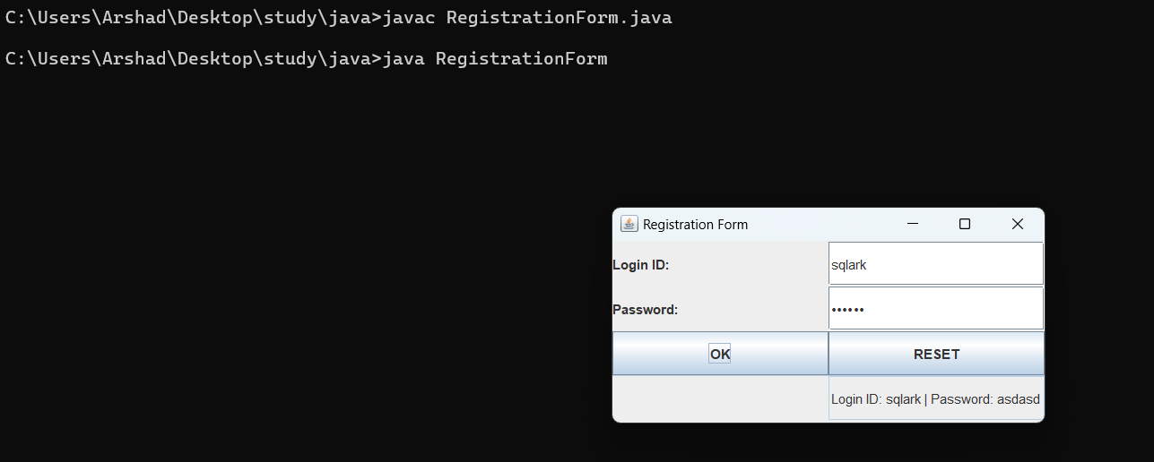

1. Write a program to create a basic calculator.

**CODE-**

import javax.swing.*;

import java.awt.*;

import java.awt.event.*;

public class BasicCalculator extends JFrame implements ActionListener {

private JTextField textField;

private JButton[] buttons;

private String[] buttonLabels = {

"7", "8", "9", "/",

"4", "5", "6", "*",

"1", "2", "3", "-",

"0", ".", "=", "+"

};

private double firstNumber, secondNumber, result;

private char operator;

public BasicCalculator() {

setTitle("Basic Calculator");

setSize(300, 400);

setDefaultCloseOperation(JFrame.EXIT_ON_CLOSE);

setLocationRelativeTo(null);

textField = new JTextField();

textField.setEditable(false);

JPanel buttonPanel = new JPanel();

buttonPanel.setLayout(new GridLayout(4, 4, 10, 10));

buttons = new JButton[buttonLabels.length];

for (int i = 0; i < buttonLabels.length; i++) {

buttons[i] = new JButton(buttonLabels[i]);

buttons[i].addActionListener(this);

buttonPanel.add(buttons[i]);

}

setLayout(new BorderLayout());

add(textField, BorderLayout.NORTH);

add(buttonPanel, BorderLayout.CENTER);

}

public void actionPerformed(ActionEvent e) {

String command = e.getActionCommand();

if (Character.isDigit(command.charAt(0)) || command.equals(".")) {

textField.setText(textField.getText() + command);

} else if (command.equals("=")) {

secondNumber = Double.parseDouble(textField.getText());

switch (operator) {

case '+':

result = firstNumber + secondNumber;

break;

case '-':

result = firstNumber - secondNumber;

break;

case '*':

result = firstNumber * secondNumber;

break;

case '/':

if (secondNumber != 0)

result = firstNumber / secondNumber;

else

result = 0; // Handling division by zero

break;

}

textField.setText(String.valueOf(result));

} else if (command.equals("C")) {

textField.setText("");

} else {

operator = command.charAt(0);

firstNumber = Double.parseDouble(textField.getText());

textField.setText("");

}

}

public static void main(String[] args) {

BasicCalculator calculator = new BasicCalculator();

calculator.setVisible(true);

}

}

**OUTPUT-**

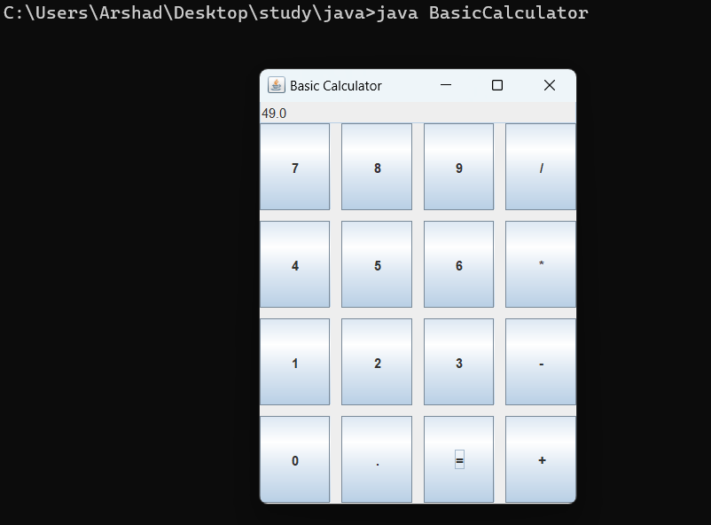

1. Display the selected fields in Details after submit button is clicked

**CODE-**

import javax.swing.*;

import java.awt.*;

import java.awt.event.*;

public class form extends JFrame implements ActionListener {

JCheckBox javaCheckbox, pythonCheckbox, cppCheckbox;

JButton submitButton, resetButton;

JLabel detailsLabel;

public form() {

setTitle("Registration Form with Details");

setSize(600, 400);

setDefaultCloseOperation(JFrame.EXIT_ON_CLOSE);

setLocationRelativeTo(null);

setLayout(new GridLayout(5, 2));

javaCheckbox = new JCheckBox("Java");

pythonCheckbox = new JCheckBox("Python");

cppCheckbox = new JCheckBox("C++");

submitButton = new JButton("Submit");

submitButton.addActionListener(this);

resetButton = new JButton("Reset");

resetButton.addActionListener(this);

detailsLabel = new JLabel("Details:");

add(javaCheckbox);

add(pythonCheckbox);

add(cppCheckbox);

add(new JLabel());

add(submitButton);

add(resetButton);

add(new JLabel());

add(new JLabel());

add(detailsLabel);

add(new JLabel());

}

public void actionPerformed(ActionEvent e) {

if (e.getSource() == submitButton) {

StringBuilder details = new StringBuilder("Selected Languages: ");

if (javaCheckbox.isSelected()) {

details.append("Java is paltform independent, ");

}

if (pythonCheckbox.isSelected()) {

details.append("Python is paltform independent, ");

}

if (cppCheckbox.isSelected()) {

details.append("C++ is paltform dependent, ");

}

// Removing the last comma and space

if (details.length() > 0) {

details.setLength(details.length() - 2);

}

detailsLabel.setText(details.toString());

} else if (e.getSource() == resetButton) {

javaCheckbox.setSelected(false);

pythonCheckbox.setSelected(false);

cppCheckbox.setSelected(false);

detailsLabel.setText("Details:");

}

}

public static void main(String[] args) {

form form = new form();

form.setVisible(true);

}

}

**OUTPUT-**

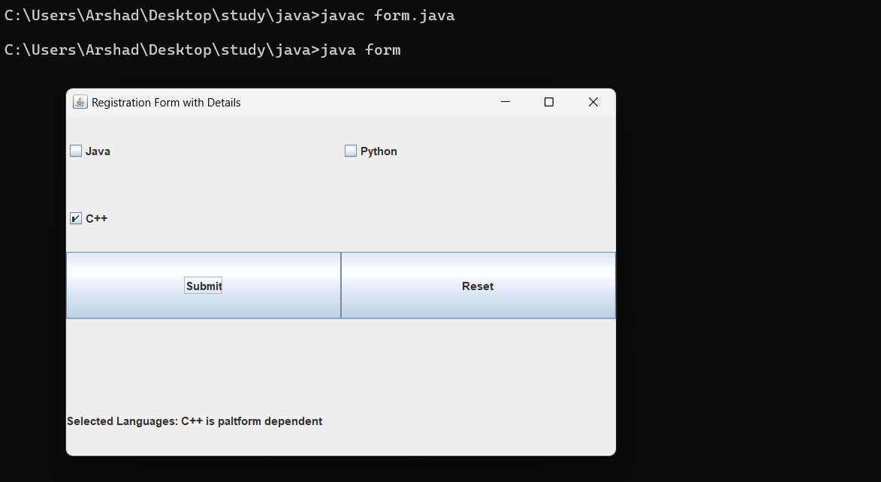

**CONCLUSION:**

I learned how to create Java GUI applications. A registration form where users input login ID and password, displaying the details upon submission. I also developed a basic calculator allowing users to perform arithmetic operations. Finally, dynamically updating UI elements based on user interactions, enhancing understanding of event handling in Java GUI programming.